DL_14
Lesson 14 – Occupations closely related to food industry
Aim: To understand what occupations are closely related to food industry.
Task 1
Write down the occupation, its branch and speciality).
Occupation | Branch | Speciality
Occupations closely related to food industry
Activities in the food industry are closely related to other economic activities:
- Business management, finance, accountancy and administration,
- Transportation and logistics,
- Information and communication technologies,
- Metalworking and machinery,
- Power engineering
To understand what occupations are involved in food company have a look at the company structure.
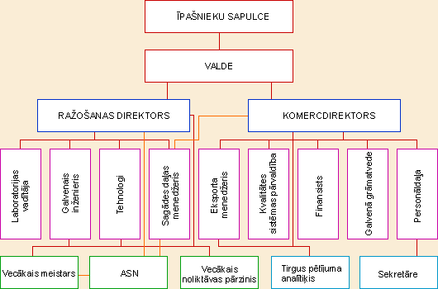

To ensure functioning of food industry, all the areas should cooperate and it is important to consider that products and areas overlap.
- Business management, finance, accountancy, administration are represented by such occupations as finance manager, economist, PR manager, project manager, lawyer, accountant, marketing specialist, HR manager, secretary, customer service representative.
- Chemistry – chemical engineer, microbiologist, technician of chemical processes.
- Agriculture – livestock specialist, veterinarian, zootechnical specialist.
- Power engineering – electrician, electrical technician, electrical equipment specialist, electronics specialist, electrical engineer.
- Metalworking – mechanical engineer, mechanical technician, metalworker, turner, welder.
- Information and communication technologies – information engineer and IT specialist.
- Transportation and logistics – logistics manager, logistics specialist, logistician.

Qualification structure of business management, finance, accountancy and administration
Qualification level | General skills | Education |  | Main occupation | Specialization
 |  | Programme | Duration full-time (approx)
5 | Higher qualification that allows to plan and carry out scientific research | 2nd level professional higher education programme | Up to 5 years upon secondary education | Senior executive
 |  |  |  |  | Marketing
 |  |  |  |  | Trade
 |  |  |  |  | HR
 |  |  |  |  | Project Management
 |  |  |  |  | Specialized top manager
 |  |  |  | Economist
 |  |  |  | Accountant
 |  |  |  | Financier
 |  |  |  | Financial analyst
 |  |  |  |  | Risk analyst
 |  |  |  |  | Active manager
 |  |  |  | Lawyer
 |  |  |  | Legal Adviser
4 | Theoretical and practical readiness that allows to perform complicated tasks as well as organize and manage other people | 1st level professional higher education programme | 2-3 years upon secondary education | Commerce specialist
 |  |  |  |  | Marketing specialist
 |  |  |  |  | Trade specialist
 |  |  |  |  | Specialized commerce specialist
 |  |  |  | Management specialist
 |  |  |  |  | Office manager
 |  |  |  |  | HR
 |  |  |  | Accountant
 |  |  |  | Finance specialist
 |  |  |  | Banking specialist
 |  |  |  | Legal assistant
 |  |  |  | Security specialist
Transportation and logistics
Logistics manager 5th qualification level
Logistics managers manage their own or other person’s business, plan, allocate and coordinate the course of business activities, assist in other areas. Head of transportation, communication, storage, supply and logistics departments work in cooperation with other top managers under the supervision of senior executives.
Logistics specialist 4th qualification level
Logistics specialist purchases goods and provides services on behalf of manufacturing, commercial and other businesses.
Logistician 3rd qualification level
Logistician purchases raw stuff, materials, half stock and ready products, ensures adequate storaging, supply and selling of ready produce; is responsible for labelling, assembling and dispatching loads, raw materials and goods; Logistician works for a small-scale or medium-size business.

Forwarding agent is responsible for customs procedures, insurance, export and import licensing and other documents.

