SP_8
Lesson 8 – Professional qualification
Aim: To understand the concept of professional qualification and levels.
Guidelines:
- During the lesson students learn about professional qualification and levels.
- During the lesson students use the worksheet.
- For Task 1 students read the text, for Task 2 they fill in the table „WHAT I KNOW” and for Task 3 they fill in the table „WHAT I HAVE LEARNT”.
Task 1
Students read the text.
The term „qualification” in regulatory acts of educational system is used as „professional qualification”, which according to the Law on Education (1998) is „evaluation of the professional mastery and education required for a certain occupation”.
According to the Law on Professional Education there are five qualification levels in the education system of Latvia that reflect „theoretical and practical proficiency that allows to perform work of certain complexity and responsibility”:
Qualification level 1 – theoretical and practical proficiency that allows to perform simple tasks in a certain practical sphere;
Qualification level 2 - theoretical and practical proficiency that allows to independently perform qualified duties
Qualification level 3 – more sophisticated theoretical and practical proficiency that allows to perform certain activities that require planning and organizing;
Qualification level 4 - theoretical and practical proficiency that allows to perform complex activities as well as organize the work and manage other specialists’ work;
Qualification level 5 – the highest qualification in the area that allows to plan and carry out scientific research in the area.
So levels of professional qualification refer to professional education only (from basic education to higher education), they do not correspond to European qualification education.
Schematically the levels are reflected in Picture 1 and Picture 2.
Picture 1. Levels of professional qualification
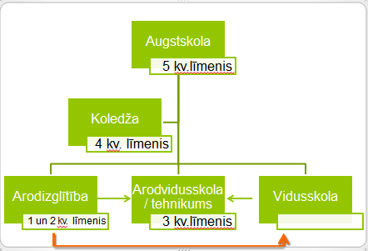

Picture 2 Education in Latvia
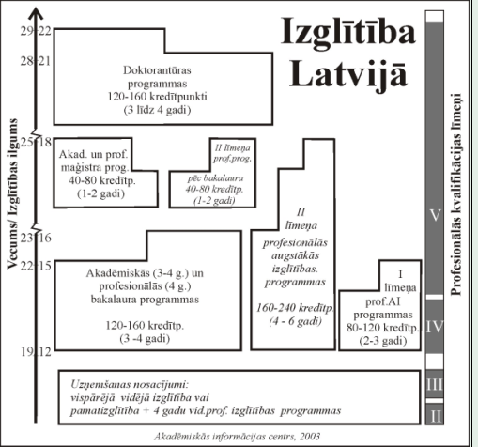

What is professional qualification?
The Law of Education says that „professional qualification is evaluation of the professional mastery and education required for a certain occupation”. So, it is a proof to the fact that a person with a certain professional qualification:
- Has received the corresponding level of education
- Has professional and general skills and abilities
- Has a document that proves this professional qualification.
Profession standard determines the set of skills and abilities required for a certain professional qualification. The register of profession standards is supervised by the National Centre for Education.

Documents of professional qualification
Professional qualification is confirmed by a professional qualification document. This document grants the right to work in a certain field and take a certain position according to the qualification level or opening a private practice upon completing certification process.
Depending on the education level and the educational institution professional qualification can be confirmed by different types of education documents.

Education document | Level of professional qualification | Education programme
Professional basic education certificate | 1 | Professional basic education
Vocational education certificate | 2 | Vocational education
Professional secondary education diploma | 3 | Professional secondary education  Professional secondary education upon general secondary education
Professional qualification certificate | 1,2,3 | Vocational education upon general secondary education  Vocational education upon basic education from the age of 18  Professional further education
1st level professional higher education diploma | 4 | 1st level professional studies (college programmes)
Professional higher education diploma and higher professional qualification diploma | 5 | 2nd level professional higher education
Professional bachelor diploma and higher professional qualification diploma | 5 | Professional bachelor study programme
Professional master diploma and higher professional qualification diploma | 5 | Professional master study programme
!!! State-approved education document of professional qualification is issued only if the study programme is accredited at the moment of graduation. The licence does not guarantee that the issued diploma will be state-approved. The information on programme accreditation is available from the institution involved in accreditation.
Task 2
Students write down the answers to the questions in the column WHAT I KNOW.
Question | WHAT I KNOW | WHAT I HAVE LEARNT
My occupation
Which qualification level does my occupation have
Where can I learn it
What diploma will I get

Task 3
Students fill in the information in the column WHAT I HAVE LEARNT of Task 2 based on the information from online sources, for example, www.niid.lv and other.

